WT ASSIGNMENT

Pratham sharma – 051

Question 1) Create a simple HTML page using basic tags.

INPUT-

Output -<html>

<head>

<title> Student Information </title>

</head>

<body>

<h4> Basic Tags</h4>

</body>

</html>

OUTPUT –

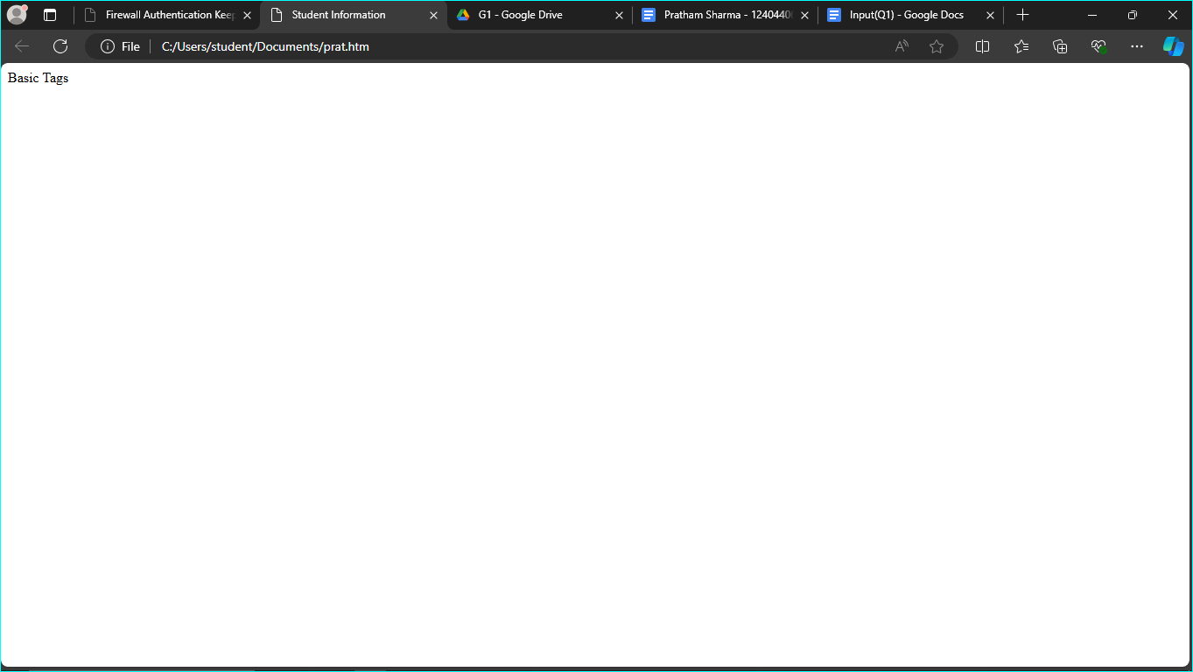

Question 2) Create a web page that displays your name to the screen.

INPUT-

<html>

<head>

<title> Student Information </title>

</head>

<body style="background-color:powderblue;">

<h4 style="background-color:Tomato;"> Student Name - Pratham Sharma </h4>

</body>

</html>

OUTPUT –

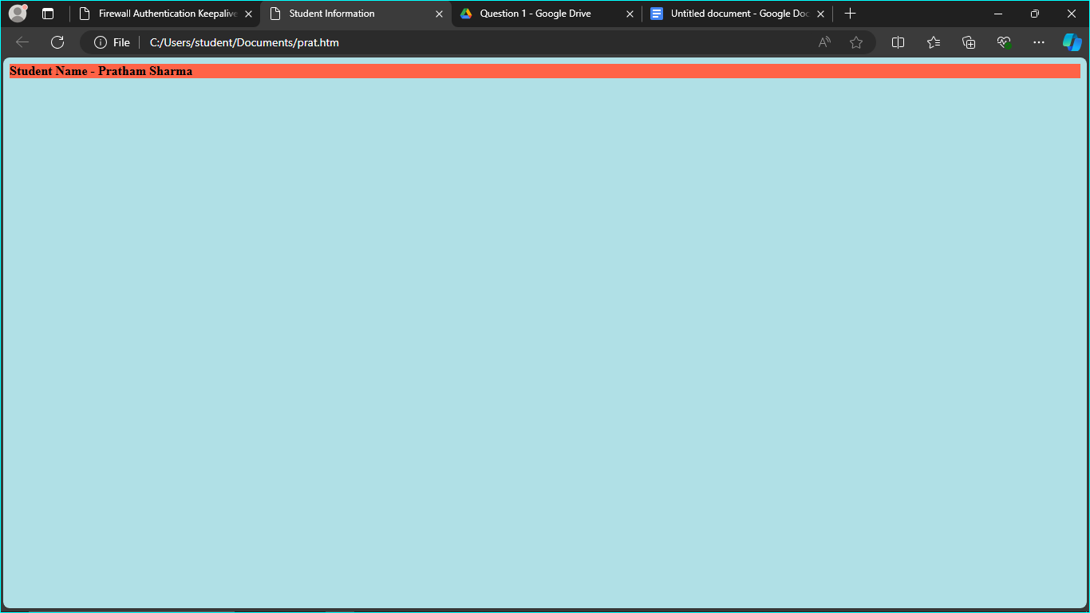

Question 3) Create a web page and show the output from 1 to 10 in separate lines.

INPUT-

<html>

<head>

<title> Student Information </title>

</head>

<body style="background-color:powderblue;">

<h4 style="background-color:Tomato;"> Student Name - Pratham Sharma </h4>

<p> 1 </p>

<p> 2 </p>

<p> 3 </p>

<p> 4 </p>

<p> 5 </p>

<p> 6 </p>

<p> 7 </p>

<p> 8 </p>

<p> 9 </p>

<p> 10 </p>

</body>

</html>

Output -

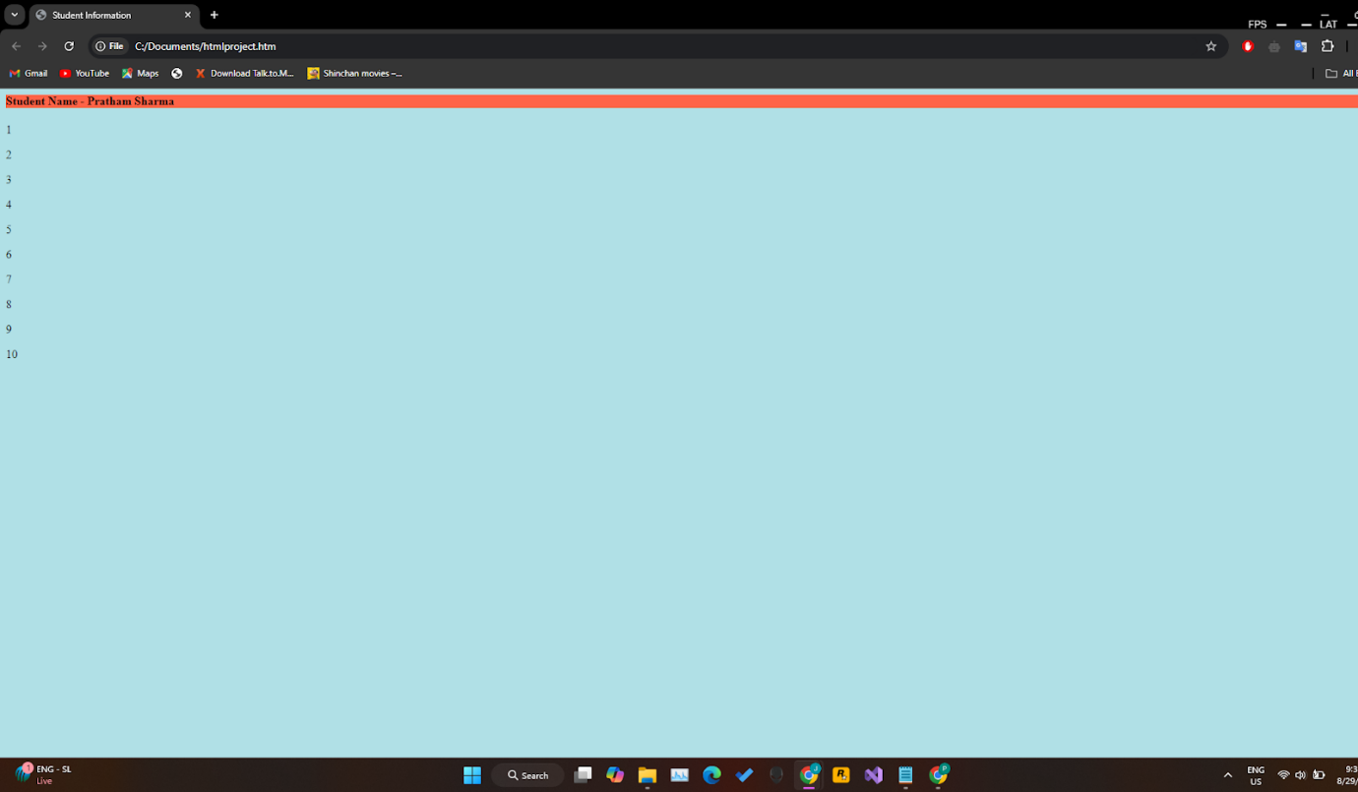

Question 4) Create a web page and show the output from 1 to 10 in separate lines, each number being in different color.

Input –

<html>

<head>

<title> Student Information </title>

</head>

<body style="background-color:powderblue;">

<h4 style="background-color:Tomato;"> Student Name - Pratham Sharma </h4>

<p style="color:red;"> 1 </p>

<p style="color:purple;"> 2 </p>

<p style="color:orange;"> 3 </p>

<p style="color:pink;"> 4 </p>

<p style="color:green;"> 5 </p>

<p style="color:blue;"> 6 </p>

<p style="color:brown;"> 7 </p>

<p style="color:yellow;"> 8 </p>

<p style="color:violet;"> 9 </p>

<p style="color:black;"> 10 </p>

</body>

</html>

Output -

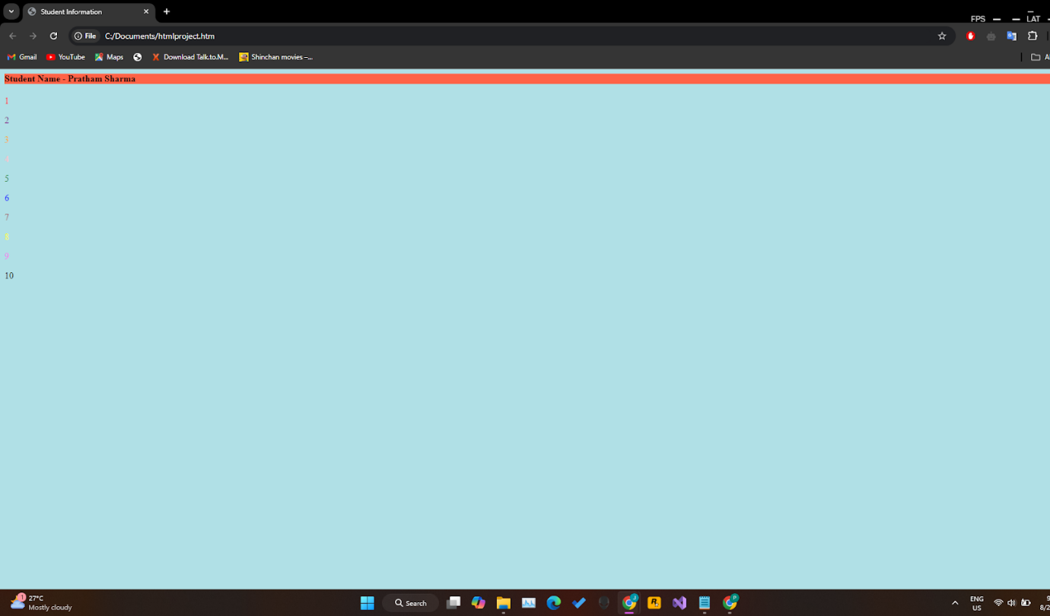

Question 5) How do I make a picture as a background on my web pages?

Input-

<html>

<head>

<title> Student Information </title>

</head>

<body style="background-color:powderblue;">

<h3 style="color:Tomato;"> Adding picture to background </h3>

<img src="https://encrypted-tbn0.gstatic.com/images?q=tbn:ANd9GcQEc9A_S6BPxCDRp5WjMFEfXrpCu1ya2OO-Lw&s">

</body>

</html>

Output -

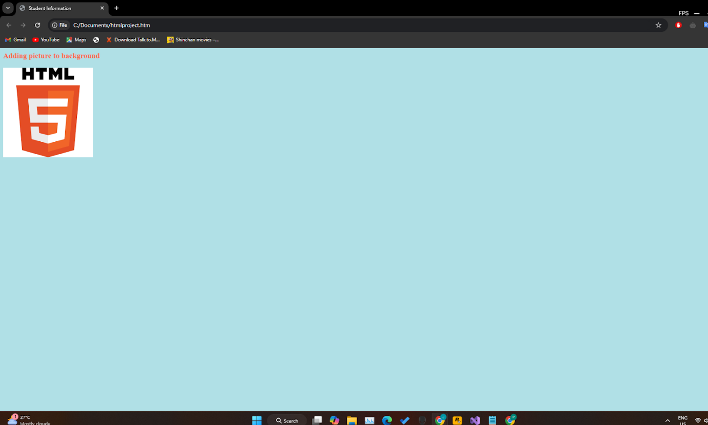

Question 6) Create a web page to print a paragraph with 4-5 sentences, each sentence shall have a different font.

Input-

<html>

<head>

<title> Student Information </title>

</head>

<body style="background-color:powderblue;">

<h5 style="Font-Family:Cursive;"> This is Paragraph one </h5>

<h4 style="Font-Family:Fantasy;"> This is Paragraph two </h4>

<h3 style="Font-Family:Helvetica;"> This is Paragraph three </h3>

<h2 style="Font-Family:Courier New;"> This is Paragraph four </h2>

<h1 style="Font-Family:Verdana New;"> This is Paragraph five</h1>

</body>

</html>

Output -

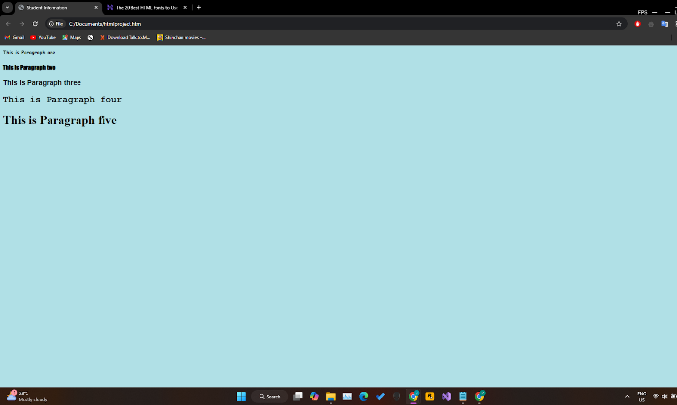

Question 7) Write HTML code to print a paragraph that is description of a book, it shall include the title of the book, its author name; name and title should be underlined and all adjectives shall be bold and Italics.

Input-

<html>

<head>

<title> Student Information </title>

</head>

<body style="background-color:powderblue;">

<p>Book name - <b><u><i> Harry Potter and the Philosopher's Stone</b></u></i> Author name - <b><u><i>J. K. Rowling</b></u></i></p>

</body>

</html>

Output -

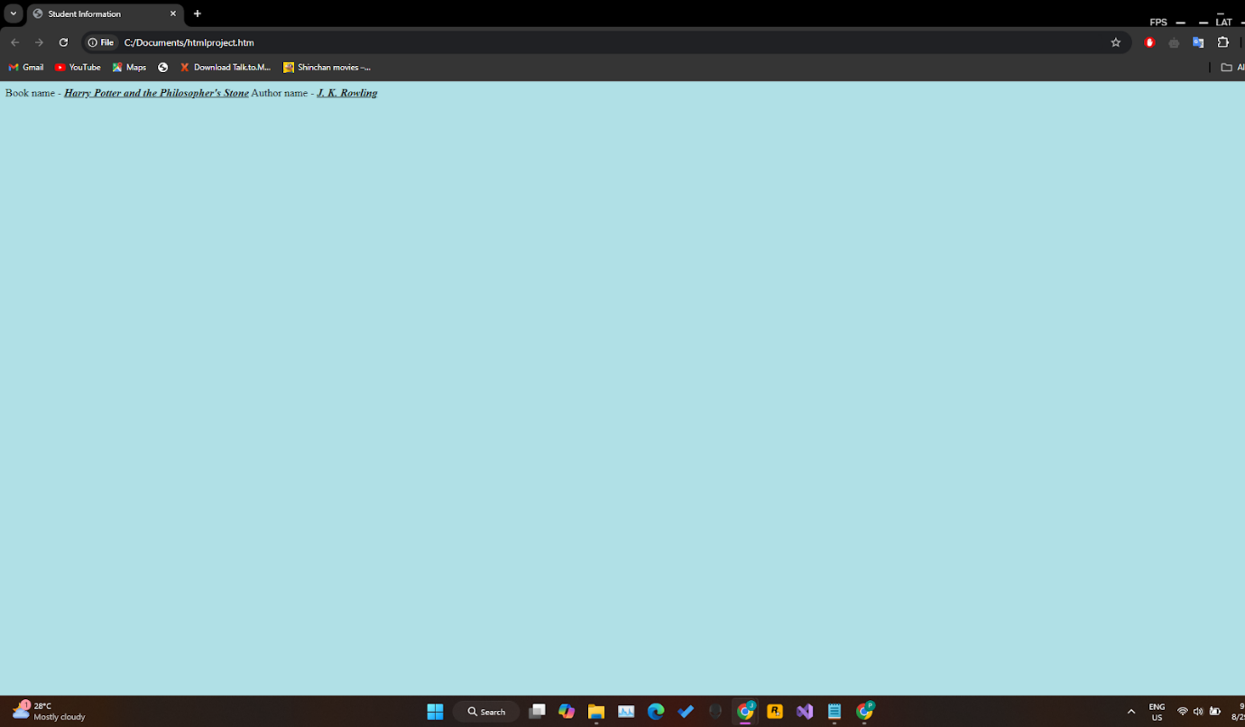

Question 8) Write HTML code to print your name using Heading tag, every letter shall be of different heading size.

INPUT-

<html>

<head>

<title> Heading Tag </title>

</head>

<body style="background-color:powderblue;">

<h1>P</h1>

<h2>R</h2>

<h3>A</h3>

<h4>T</h4>

<h5>H</h5>

<h6>A</h6>

<h1>M</h1>

</body>

</html>

Output -

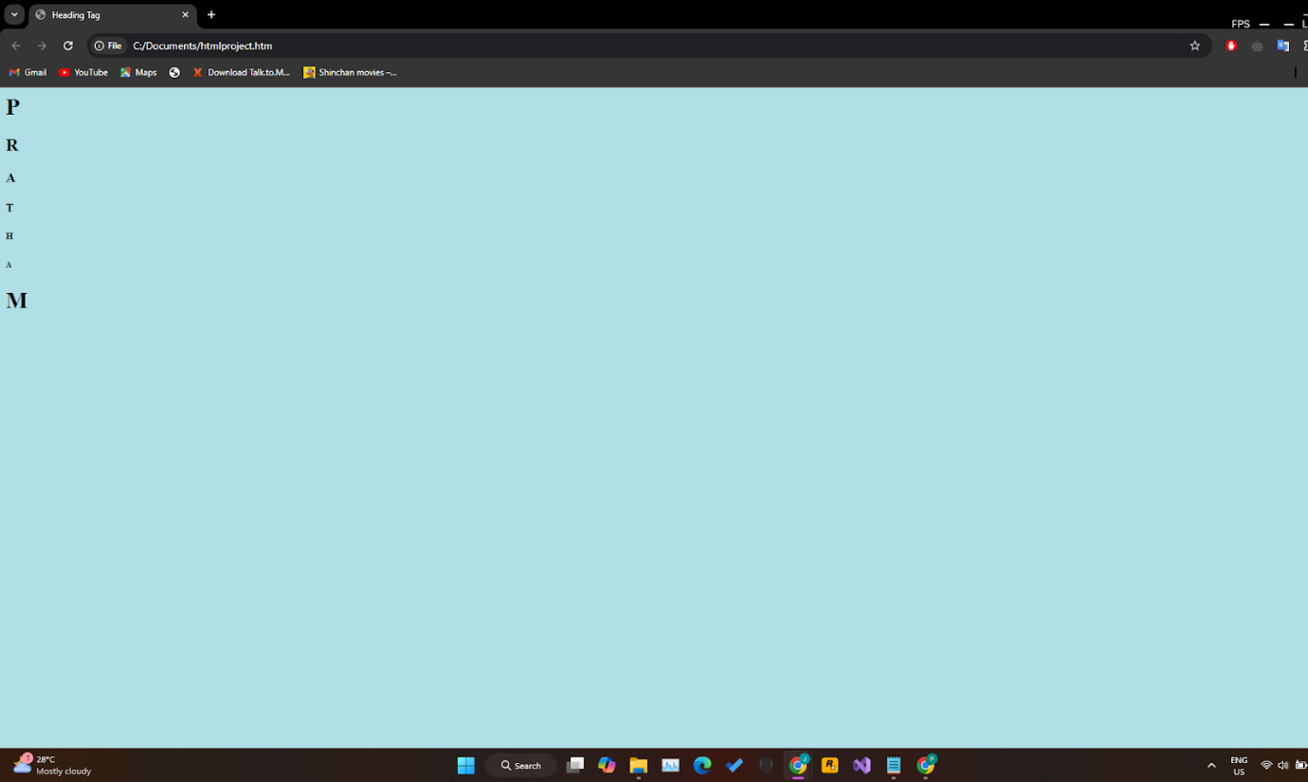

Question 9) Write HTML code to print the sequence of numbers 1-20. Each number shall be in different line with number 2 next to it as subscript, an equal sign and the result.

INPUT-

<html>

<head>

<title> Heading Tag </title>

</head>

<body style="background-color:powderblue;">

    <p>1<sub>2</sub> = 2</p>

    <p>2<sub>2</sub> = 4</p>

    <p>3<sub>2</sub> = 6</p>

    <p>4<sub>2</sub> = 8</p>

    <p>5<sub>2</sub> = 10</p>

    <p>6<sub>2</sub> = 12</p>

    <p>7<sub>2</sub> = 14</p>

    <p>8<sub>2</sub> = 16</p>

    <p>9<sub>2</sub> = 18</p>

    <p>10<sub>2</sub> = 20</p>

    <p>11<sub>2</sub> = 22</p>

    <p>12<sub>2</sub> = 24</p>

    <p>13<sub>2</sub> = 26</p>

    <p>14<sub>2</sub> = 28</p>

    <p>15<sub>2</sub> = 30</p>

    <p>16<sub>2</sub> = 32</p>

    <p>17<sub>2</sub> = 34</p>

    <p>18<sub>2</sub> = 36</p>

    <p>19<sub>2</sub> = 38</p>

    <p>20<sub>2</sub> = 40</p>

</body>

</html>

Output -

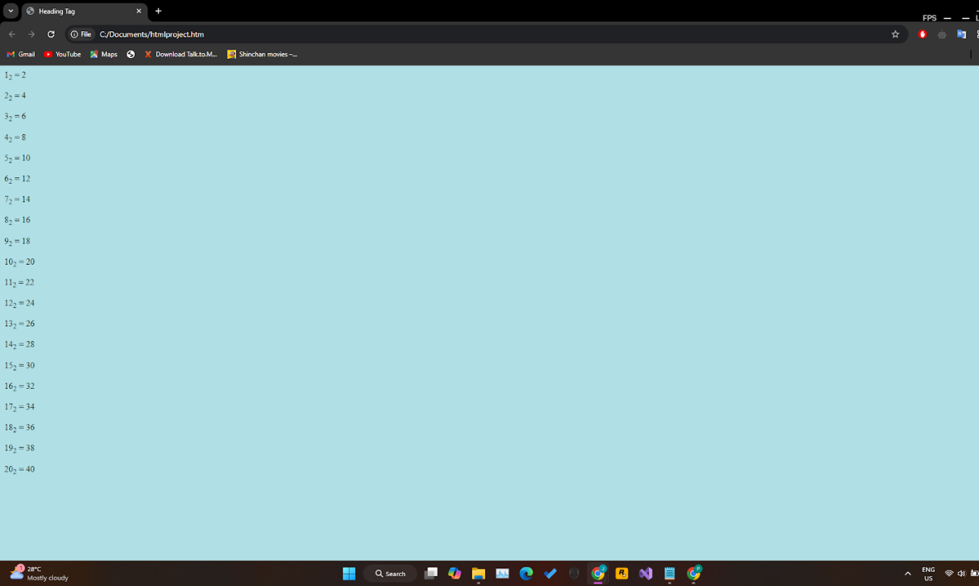

Question 10) Write HTML code to display an image with border of size with width 200, height 200 pixels, leaving Hspace and Vspace of your choice with image hanging in the right side on the screen.

INPUT-

Input -

<html>

<head>

    <title>Image Example</title>

</head>

<body>

    <img src="https://encrypted-tbn0.gstatic.com/images?q=tbn:ANd9GcQEc9A_S6BPxCDRp5WjMFEfXrpCu1ya2OO-Lw&s" width="200" height="200" style="border: 5px solid black;" align="right">

</body>

</html>

Output-

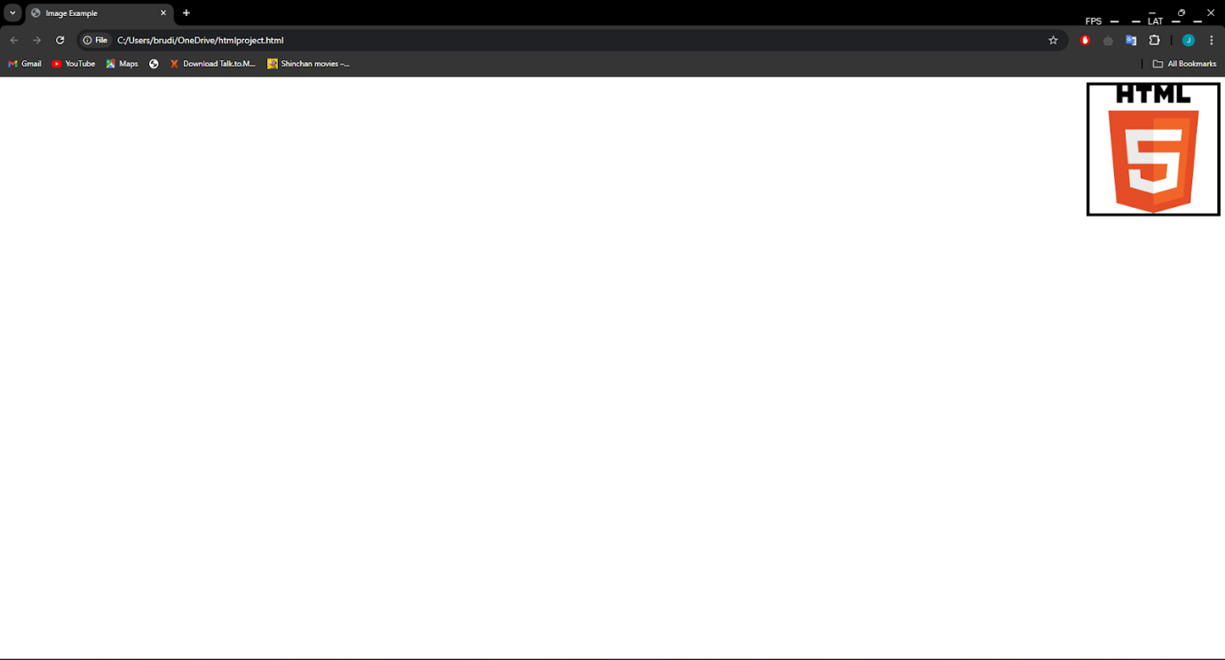

Question 11) write a html code to create a web page with heading. the heading shall be displayed at the top-centre of the page and the image shall be at the centre , just below the heading .

INPUT-

<html>

<head>

    <title>Web Page with Centered Heading and Image</title>

</head>

<body>

    <h1 style="text-align: center;">Heading</h1>

    <div style="text-align: center;">

        <img src="https://encrypted-tbn0.gstatic.com/images?q=tbn:ANd9GcQEc9A_S6BPxCDRp5WjMFEfXrpCu1ya2OO-Lw&s" width="200" height="200" alt="Centered Image">

    </div>

</body>

</html>

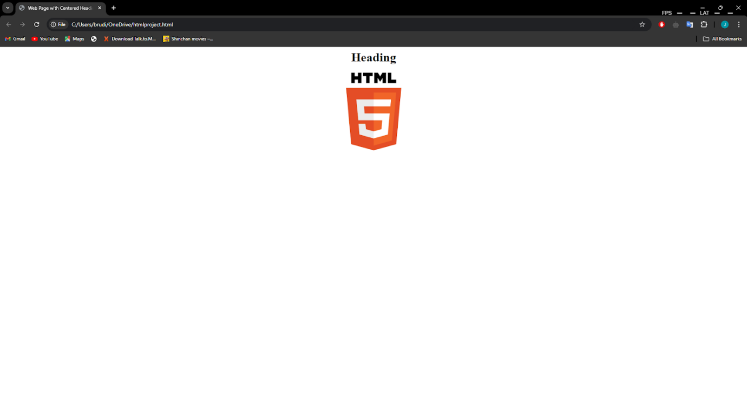

Question 12) Write HTML code using Multimedia tags.

INPUT-

<html>

<head>

<title> multimedia tags</title>

</head>

<body>

<h1> multimedia tags: </h1>

<h1>img</h1>

<center>

<img src="C:\Users\Prat\Downloads\image.jpg"

alt="scenery" height="450" , width="450"/>

<h1> audio </h1>

<audio src="C:\Users\Prat\Downloads\Audio .mp3" controls/>

</body>

</html>

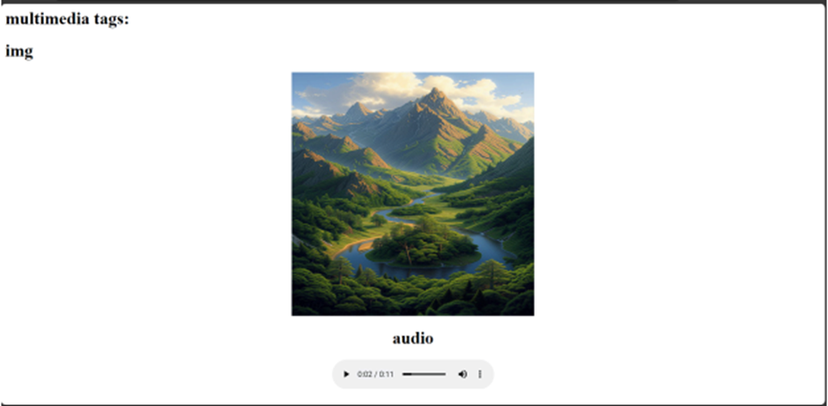

Question 13) Create a Table using Rowspan and Colspan taking example of student Record .

INPUT-

<!DOCTYPE html>

<html lang="en">

<head>

<meta charset="UTF-8">

<meta name="viewport" content="width=device-width, initial-scale=1.0">

<title>Student Table with Rowspan and Colspan</title>

</head>

<body>

<h2>Student Information</h2>

<table border="1">

<tr>

<th rowspan="2">Name</th>

<th colspan="3">Subjects</th>

<th rowspan="2">Overall Grade</th>

</tr>

<tr>

<th>Math</th>

<th>Science</th>

<th>English</th>

</tr>

<tr>

<td>Prat</td>

<td>A</td>

<td>B</td>

<td>A</td>

<td>A</td>

</tr>

<tr>

<td>Prath</td>

<td>B</td>

<td>A</td>

<td>A</td>

<td>A</td>

</tr>

<tr>

<td>Pratham</td>

<td>C</td>

<td>B</td>

<td>B</td>

<td>B</td>

</tr>

</table>

</body>

</html>

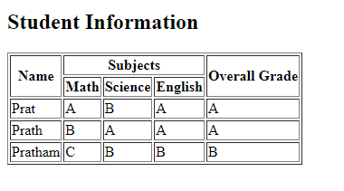

Question 14) Write HTML code using table tag

|  |
| --- |
| and cellpadding and cell spacing as its attributes.  INPUT-  <!DOCTYPE html>  <html lang="en">  <head>  <meta charset="UTF-8">  <meta name="viewport" content="width=device-width, initial-scale=1.0">  <title>Table with Cellpadding and Cellspacing</title>  </head>  <body>  <h2>Student Grades</h2>  <table border="1" cellpadding="10" cellspacing="5">  <tr>  <th>Name</th>  <th>Math</th>  <th>Science</th>  <th>English</th>  <th>Overall Grade</th>  </tr>  <tr>  <td>prat</td>  <td>A</td>  <td>B</td>  <td>A</td>  <td>A</td>  </tr>  <tr>  <td>prath</td>  <td>B</td>  <td>A</td>  <td>A</td>  <td>A</td>  </tr>  <tr>  <td>pratham</td>  <td>C</td>  <td>B</td>  <td>B</td>  <td>B</td>  </tr>  </table>  </body>  </html>  Output –    Question 15) Create unordered, ordered and definition Lists taking example of your subjects in MCA IST, IInd and IIIrd Semester.  INPUT-  <!DOCTYPE html>  <html lang="en">  <head>  <meta charset="UTF-8">  <meta name="viewport" content="width=device-width, initial-scale=1.0">  <title>MCA Semester Subjects</title>  </head>  <body>  <h2>Subjects in MCA</h2>  <!-- Unordered List for 1st Semester -->  <h3>1st Semester Subjects</h3>  <ul>  <li>Programming in C</li>  <li>Data Structures</li>  <li>Computer Organization</li>  <li>Discrete Mathematics</li>  <li>Introduction to Management</li>  </ul>  <!-- Ordered List for 2nd Semester -->  <h3>2nd Semester Subjects</h3>  <ol>  <li>Database Management Systems</li>  <li>Object-Oriented Programming</li>  <li>Operating Systems</li>  <li>Computer Networks</li>  <li>Software Engineering</li>  </ol>  <!-- Definition List for 3rd Semester -->  <h3>3rd Semester Subjects</h3>  <dl>  <dt>Artificial Intelligence</dt>  <dd>Study of AI principles, algorithms, and applications.</dd>  <dt>Machine Learning</dt>  <dd>Introduction to machine learning models and data analysis techniques.</dd>  <dt>Web Technologies</dt>  <dd>Fundamentals of web development, including HTML, CSS, and JavaScript.</dd>  <dt>Data Mining</dt>  <dd>Techniques for extracting useful information from large datasets.</dd>  <dt>Advanced Java Programming</dt>  <dd>In-depth study of Java for enterprise applications.</dd>  </dl>  </body>  </html>  Output- |
| Question 16) Write HTML code using and tag with all its attributes .  INPUT-  <!DOCTYPE html>  <html lang="en">  <head>  <meta charset="UTF-8">  <title>Example of Frameset and Frame</title>  </head>  <frameset cols="25%,50%,25%">  <frame src="navigation.html" name="navigation" scrolling="auto" noresize  title="Navigation Frame" frameborder="1">  <frame src="content.html" name="content" scrolling="yes" title="Content Frame"  frameborder="1">  <frame src="advertisement.html" name="advertisement" scrolling="no" noresize  title="Advertisement Frame" frameborder="1">  </frameset>  <noframes>  <body>  <p>This website requires a browser that supports frames.</p>  </body>  </noframes>  </html> |
| Question 17 Write HTML code to design a form in HTML using controls and buttons such as Teaxtbox, Textarea, password, submit button, browse button, drop-down menu  INPUT-  <!DOCTYPE html>  <html lang="en">  <head>  <meta charset="UTF-8">  <meta name="viewport" content="width=device-width, initial-scale=1.0">  <title>Sample Form</title>  </head>  <body>  <h2>User Registration Form</h2>  <form action="/submit" method="post">  <label for="name">Name:</label><br>  <input type="text" id="name" name="name" required><br><br>  <label for="password">Password:</label><br>  <input type="password" id="password" name="password" required><br><br>  <label for="address">Address:</label><br>  <textarea id="address" name="address" rows="4" cols="30" placeholder="Enter your address here"></textarea><br><br>  <label for="profilePicture">Upload Profile Picture:</label><br>  <input type="file" id="profilePicture" name="profilePicture" accept="image/*"><br><br>  <label for="gender">Gender:</label><br>  <select id="gender" name="gender">  <option value="male">Male</option>  <option value="female">Female</option>  <option value="other">Other</option>  </select><br><br>  <input type="submit" value="Submit">  </form>  </body>  </html>  Output –    Question 18. Write HTML code to design a Registration Form in HTML.  INPUT-  <!DOCTYPE html>  <html lang="en">  <head>  <meta charset="UTF-8">  <meta name="viewport" content="width=device-width, initial-scale=1.0">  <title>Registration Form</title>  </head>  <body>  <h2>Registration Form</h2>  <form action="/submit_registration" method="post">  <label for="name">Full Name:</label><br>  <input type="text" id="name" name="name" required><br><br>  <label for="email">Email:</label><br>  <input type="email" id="email" name="email" required><br><br>  <label for="password">Password:</label><br>  <input type="password" id="password" name="password" required><br><br>  <label for="phone">Phone Number:</label><br>  <input type="tel" id="phone" name="phone" pattern="[0-9]{10}" required placeholder="10-digit phone number"><br><br>  <label>Gender:</label><br>  <input type="radio" id="male" name="gender" value="male">  <label for="male">Male</label><br>  <input type="radio" id="female" name="gender" value="female">  <label for="female">Female</label><br>  <input type="radio" id="other" name="gender" value="other">  <label for="other">Other</label><br><br>  <label for="country">Country:</label><br>  <select id="country" name="country" required>  <option value="india">India</option>  <option value="usa">United States</option>  <option value="canada">Canada</option>  <option value="australia">Australia</option>  <option value="uk">United Kingdom</option>  </select><br><br>  <label for="address">Address:</label><br>  <textarea id="address" name="address" rows="4" cols="30" placeholder="Enter your address"></textarea><br><br>  <input type="checkbox" id="terms" name="terms" required>  <label for="terms">I agree to the Terms and Conditions</label><br><br>  <input type="submit" value="Register">  </form>  </body>  </html>    Question 19) Write HTML code to design a student admission Form in HTML.  INPUT-  <!DOCTYPE html>  <html lang="en">  <head>  <meta charset="UTF-8">  <meta name="viewport" content="width=device-width, initial-scale=1.0">  <title>Student Admission Form</title>  </head>  <body>  <h2>Student Admission Form</h2>  <form action="/submit_admission" method="post">  <fieldset>  <legend>Personal Information</legend>  <!-- Full Name -->  <label for="fullName">Full Name:</label><br>  <input type="text" id="fullName" name="fullName" required><br><br>  <!-- Date of Birth -->  <label for="dob">Date of Birth:</label><br>  <input type="date" id="dob" name="dob" required><br><br>  <!-- Gender (Radio Buttons) -->  <label>Gender:</label><br>  <input type="radio" id="male" name="gender" value="male">  <label for="male">Male</label><br>  <input type="radio" id="female" name="gender" value="female">  <label for="female">Female</label><br>  <input type="radio" id="other" name="gender" value="other">  <label for="other">Other</label><br><br>  </fieldset>  <fieldset>  <legend>Contact Details</legend>  <label for="address">Address:</label><br>  <textarea id="address" name="address" rows="4" cols="30" required placeholder="Enter your address"></textarea><br><br>  <label for="phone">Phone Number:</label><br>  <input type="tel" id="phone" name="phone" pattern="[0-9]{10}" required placeholder="10-digit phone number"><br><br>  <!-- Email -->  <label for="email">Email:</label><br>  <input type="email" id="email" name="email" required><br><br>  </fieldset>  <fieldset>  <legend>Academic Information</legend>  <label for="lastSchool">Last School Attended:</label><br>  <input type="text" id="lastSchool" name="lastSchool" required><br><br>  <label for="qualification">Highest Qualification:</label><br>  <select id="qualification" name="qualification" required>  <option value="highschool">High School</option>  <option value="intermediate">Intermediate</option>  <option value="bachelor">Bachelor's Degree</option>  <option value="other">Other</option>  </select><br><br>  <label for="percentage">Percentage Scored:</label><br>  <input type="number" id="percentage" name="percentage" min="0" max="100" required placeholder="Percentage (%)"><br><br>  </fieldset>  <fieldset>  <legend>Upload Documents</legend>  <label for="photo">Upload Passport Size Photo:</label><br>  <input type="file" id="photo" name="photo" accept="image/*" required><br><br>  <label for="marksheet">Upload Marksheet:</label><br>  <input type="file" id="marksheet" name="marksheet" accept=".pdf, .jpg, .jpeg, .png" required><br><br>  </fieldset>  <input type="checkbox" id="terms" name="terms" required>  <label for="terms">I confirm that the information provided is accurate to the best of my knowledge.</label><br><br>  <!-- Submit Button -->  <input type="submit" value="Submit Admission Form">  </form>  </body>  </html>  Output –    Question 20) Create a proper home page of your own using any components and styles. INPUT-  <!DOCTYPE html>  <html lang="en">  <head>  <meta charset="UTF-8">  <meta name="viewport" content="width=device-width, initial-scale=1.0">  <title>Pratham Sharma's Homepage</title>  <style>  * {  margin: 0;  padding: 0;  box-sizing: border-box;  font-family: Arial, sans-serif;  }    header {  background-color: #4CAF50;  color: white;  padding: 20px;  text-align: center;  }    nav {  background-color: #333;  overflow: hidden;  }    nav ul {  list-style-type: none;  margin: 0;  padding: 0;  }    nav ul li {  float: left;  }    nav ul li a {  display: block;  color: white;  text-align: center;  padding: 14px 20px;  text-decoration: none;  }    nav ul li a:hover {  background-color: #ddd;  color: black;  }    .main-content {  padding: 20px;  }    .section {  margin-bottom: 20px;  }    h2 {  color: #4CAF50;  }    footer {  background-color: #333;  color: white;  text-align: center;  padding: 10px;  position: fixed;  bottom: 0;  width: 100%;  }  </style>  </head>  <body>  <header>  <h1>Welcome to Pratham Sharma's Homepage</h1>  <p>A glimpse into my world, interests, and projects</p>  </header>  <nav>  <ul>  <li><a href="#about">About Me</a></li>  <li><a href="#projects">Projects</a></li>  <li><a href="#blog">Blog</a></li>  <li><a href="#contact">Contact</a></li>  </ul>  </nav>  <div class="main-content">  <section id="about" class="section">  <h2>About Me</h2>  <p>Hi, I'm Pratham Sharma, a 20-year-old boxing enthusiast, AI and ML student, and aspiring software developer. I have a passion for learning about the universe, existential questions, and exploring creative projects in programming.</p>  </section>  <section id="projects" class="section">  <h2>Projects</h2>  <p>Here are some of my recent projects:</p>  <ul>  <li> Extension for the Earth API</li>  <li>Java-based Packet Logger for analyzing network data</li>  <li>Game Development Series</li>  </ul>  </section>  <section id="blog" class="section">  <h2>Blog</h2>  <p>Check out my latest thoughts and experiences:</p>  <ul>  <li><a href="#">Finding Purpose in Boxing and Fitness</a></li>  <li><a href="#">A Journey Through AI and Machine Learning</a></li>  <li><a href="#">Existential Questions: What Lies Beyond?</a></li>  </ul>  </section>  <section id="contact" class="section">  <h2>Contact</h2>  <p>If you'd like to get in touch, feel free to reach out via email or social media.</p>  <ul>  <li>Email: pratham@example.com</li>  <li>Twitter: <a href="#">@PrathamSharma</a></li>  <li>LinkedIn: <a href="#">Pratham Sharma</a></li>  </ul>  </section>  </div>  <footer>  <p>&copy; 2024 Pratham Sharma. All rights reserved.</p>  </footer>  </body>  </html>  Output – |